The Solar System
Name:_______________________________________ Block:_____________________________
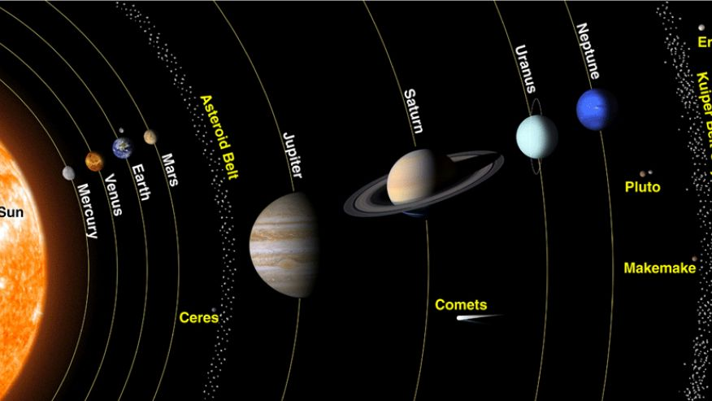
Our Solar System is made up of:

Planets are grouped into two categories:
Terrestrial: ______________________________________________________________________________________
Characteristics:

Jovian: ___________________________________________________________________________________________
Characteristics:

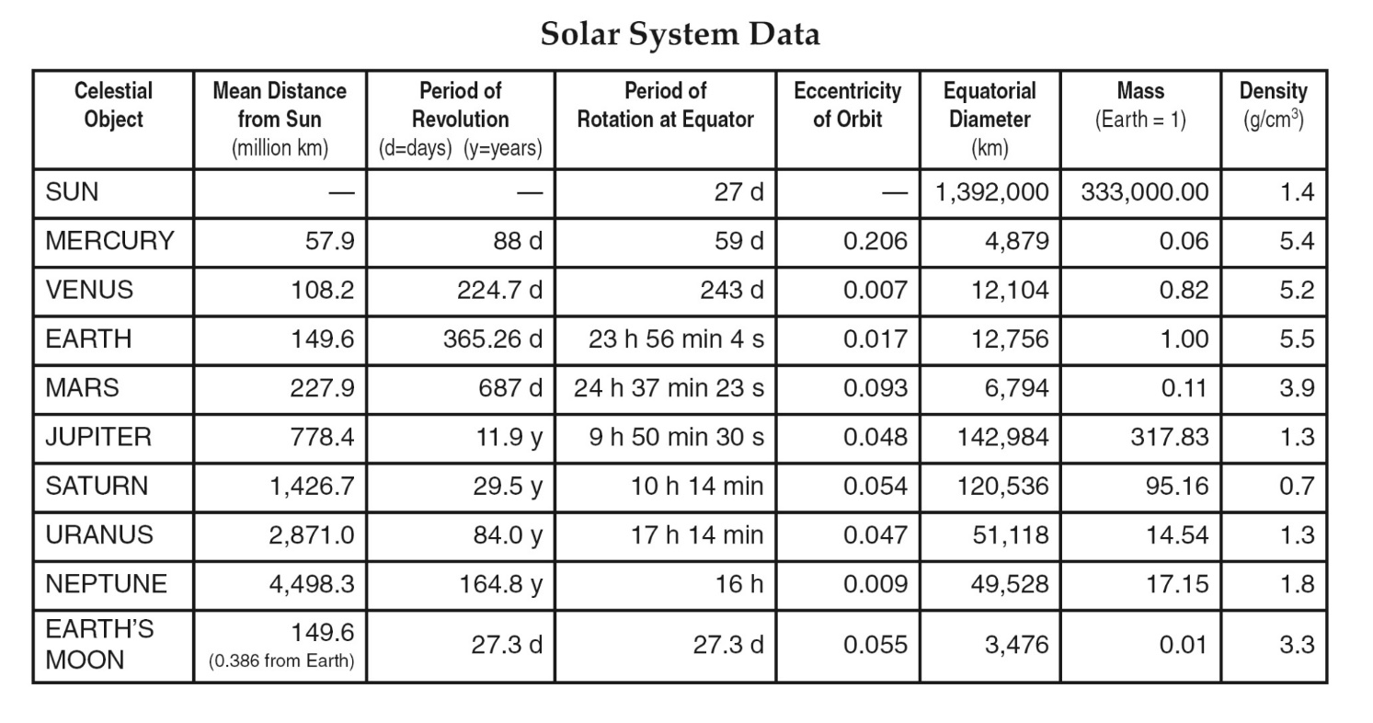
Data on the planets can be found on page ______ of the ESRT!

To accurately compare the scaled sizes of planets to one another:

